Translational Research Story Template

For more information about stories as evaluation data see:
https://news.nnlm.gov/neo/2017/11/03/beyond-anecdotes-story-collection-methods-for-program-evaluation/

NIEHS Translational Research Framework

Use this graphic to find potential translational activities that might be part of your story.
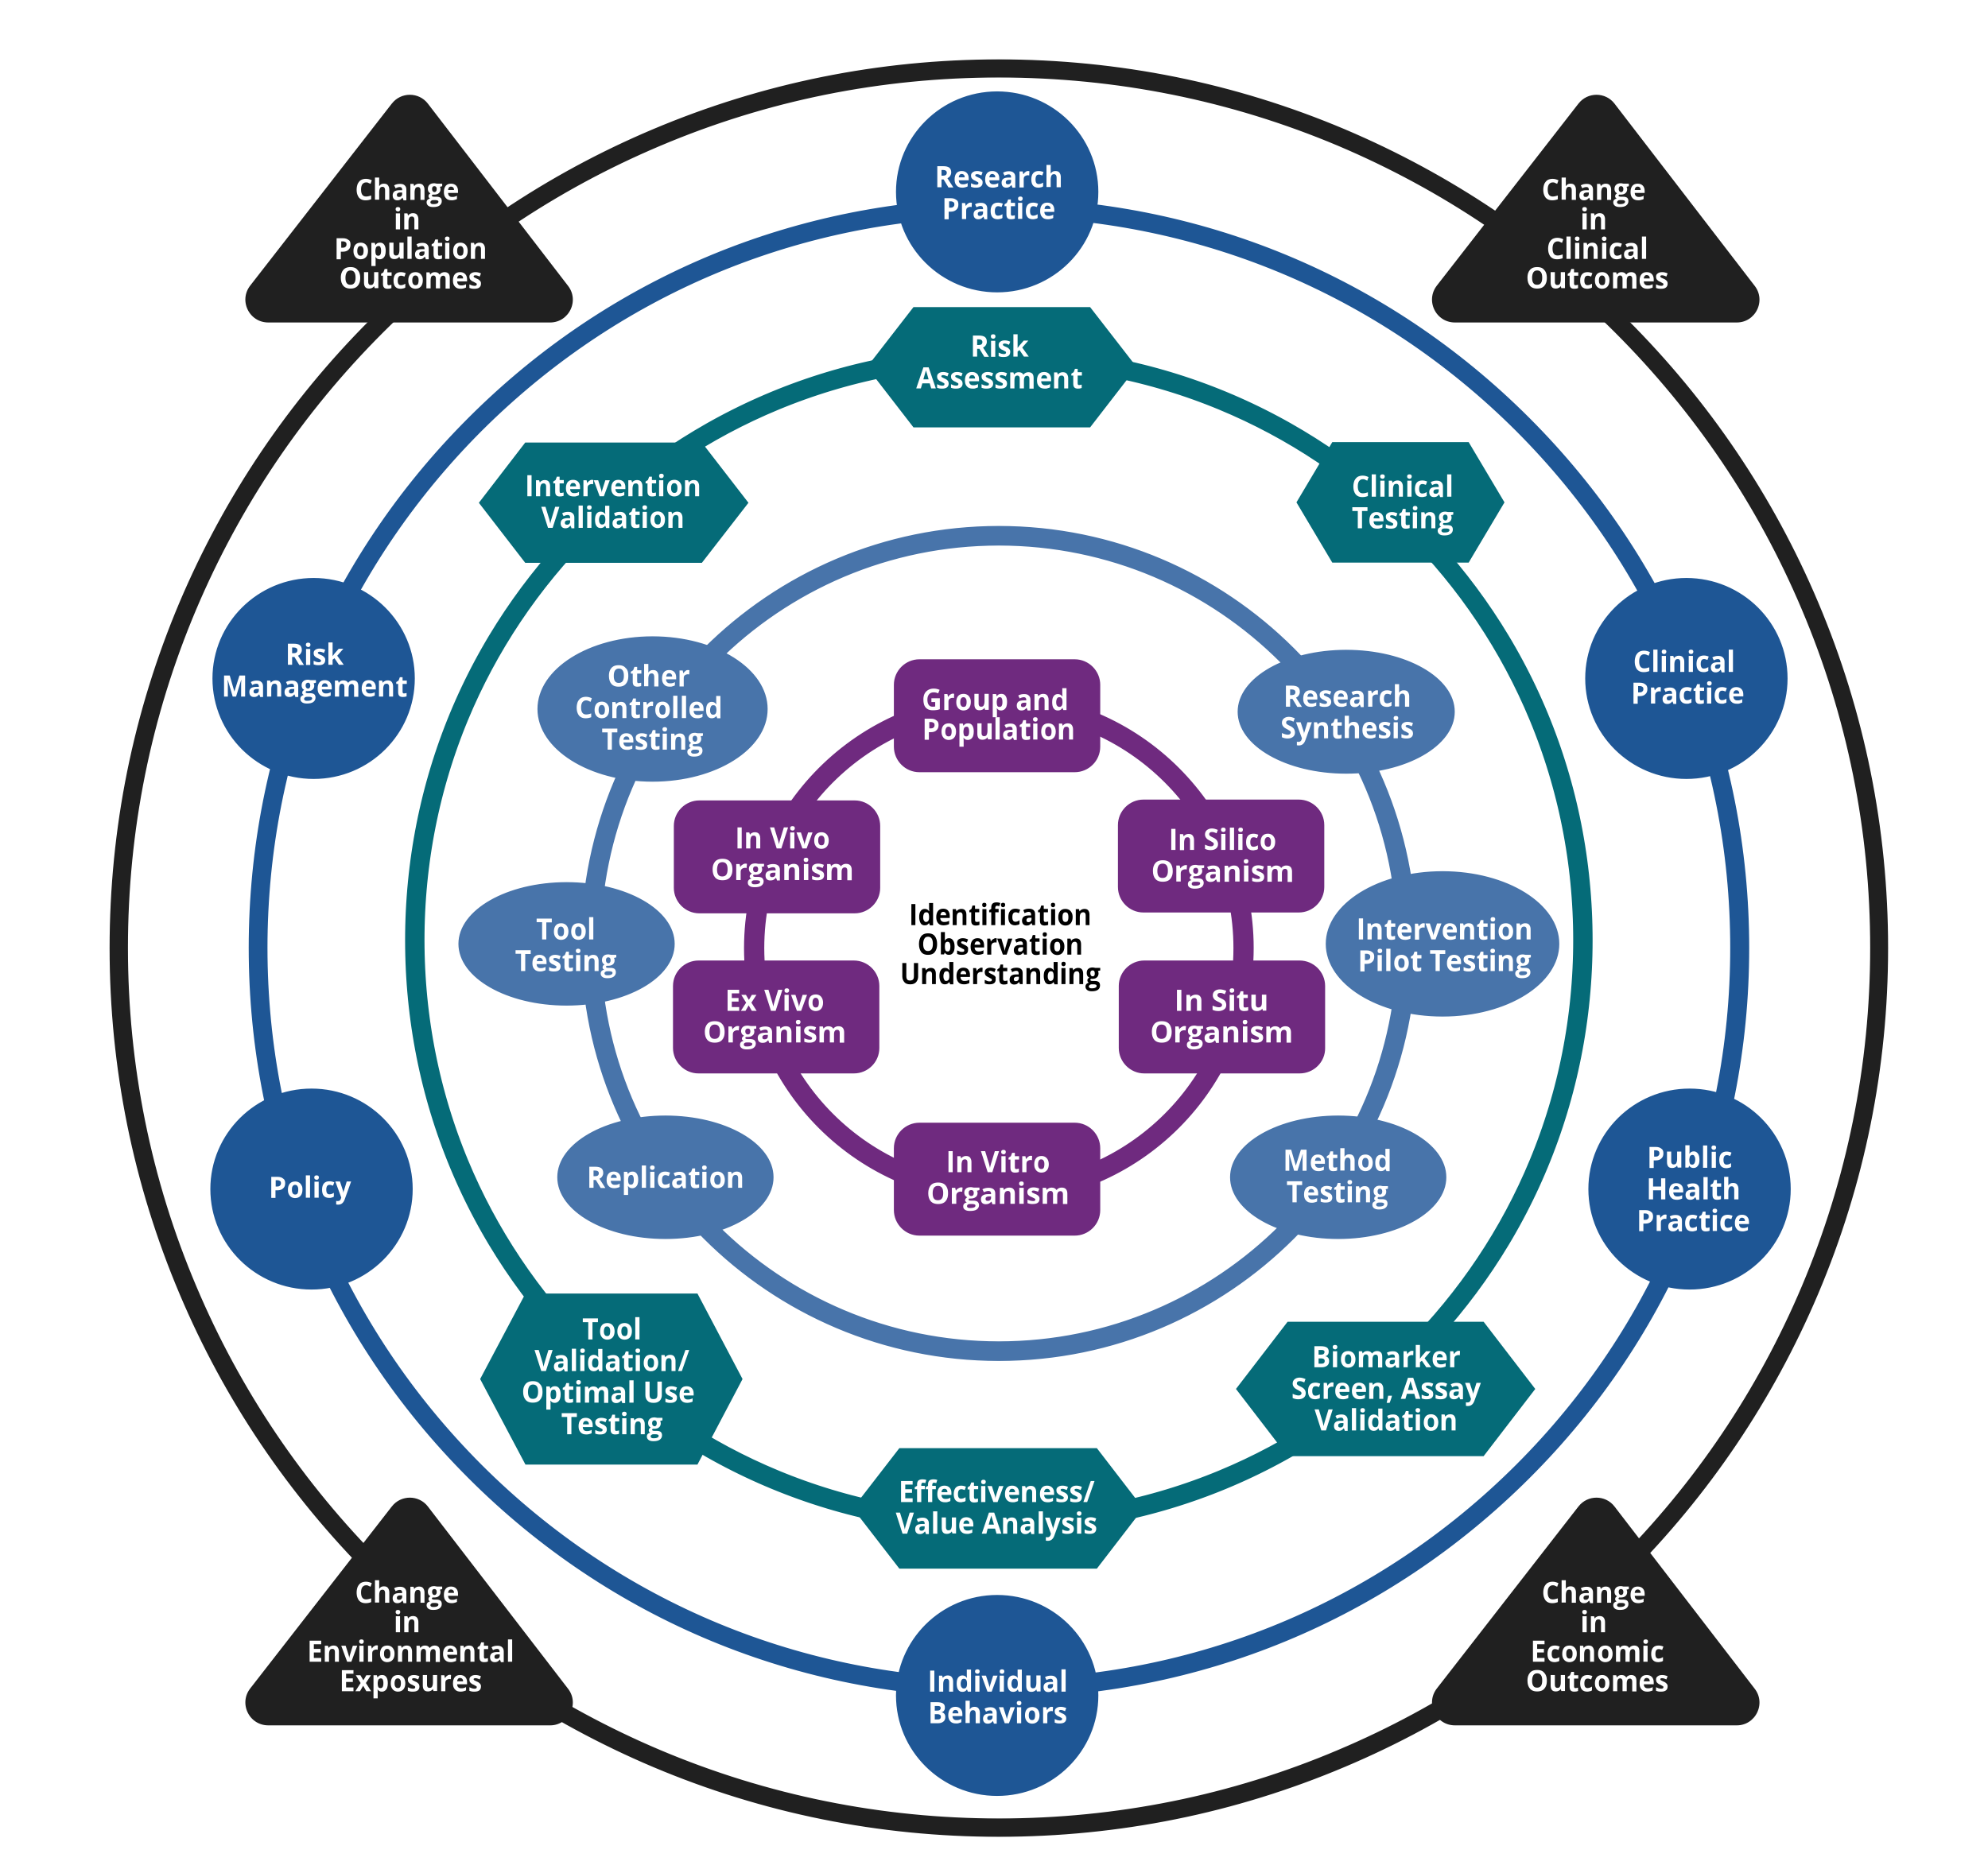

Story Outline:

Use this page to jot down the main points of your translational story.

PI(s):

Grant Number(s):

Grant Title(s):

Background/Context:

Key Translational Milestones:
- Starting Point

- Milestone 1
- Milestone 2
- Milestone 3
- Milestone 4
- Add more as needed….

Translational Bridge Details:
You can complete this page for each translational bridge you want to document. Answering the questions under the bridge graphic will help you think about context and give you extra details to enrich your story.

Bridge From:
- (Describe the starting point of the translational research story)

Bridge To: (Indicate Ring/Node)

Select one of the five rings and describe translational activity

Fundamental Science Interactions Ring
Driver:

Experimental Setting:
Organism:

Translational Research Ring/Node:
Timeframe:
Collaborators:
- Collaborator 1
- Collaborator 2
- Collaborator 3

Citations:

Citation 1
Citation 2
Citation 3

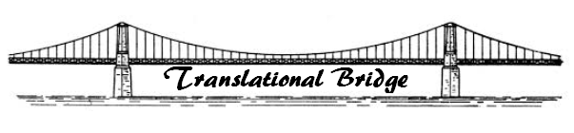

Translational Narrative:
What led to the next step?
How did the idea evolve?
Who was involved?
What needed to happen (collaborations, tools, technologies, serendipity) to cross the translational bridge?
How did you know what to do next?

